**面试题练习**

# 行为面试（STAR[1]）：

1. Describe a time when you talk in front of a lot of people without preparation;

S: 在HCR公司实习时，客户希望根据顾客的行为判断顾客对品牌感兴趣的程度，我独自对70个顾客可能会产生的行为进行采集，建立数学模型为每一个行为判断其重要性，并给予分数作为顾客的活跃积分

T: 在与客户的大型会议中，HCR团队需要对该模型做出解释

A: 考虑到该项目是我自己独立执行的，团队中其他的成员对我的数学模型并不熟悉，在客户对负责人抛出一系列原理上的问题后，本来只负责记录会议内容的我在和组长请示后，主动阐述了自己的建模思路

R: 最后，获得了客户对该模型的肯定，并根据模型进行行为触点设计和积分规则设定。通过这次无准备的展示，我对自己的临场表现能力有了更准确的评估，我认为这次成功源于我对所学知识的熟练运用和对原理的清晰了解，以及对客户需求的正确判断。

S: When I was an intern at HCR, the client wanted to determine the level of interest in the brand based on customer behavior. I worked alone to collect 70 possible customer behaviors, build a mathematical model to determine the importance of each behavior, and assign a score as the customer's activity points.

T: In a large meeting with the client, the HCR team needed to explain the model

A: Considering that I was executing the project independently, the other team members were not familiar with my mathematical model, and after the client threw a series of questions to the person in charge about the principle, I took the initiative to explain my modeling ideas after asking the team leader to record the meeting.

R: Finally, I got the client's approval of the model and proceeded to design the behavioral contact points and set the integration rules according to the model. Through this unprepared presentation, I had a more accurate assessment of my ability to perform on the spot. I think this success came from my proficient application of what I learned and my clear understanding of the principles, as well as the correct judgment of the customer's needs.

1. Describe a time when you have a misunderstanding/miscommunication and how you handle it;

当我在和2个有不同擅长领域的团队成员准备美国大学生数学竞赛时，我们需要完成对于鱼群迁移方向预测的数学建模。在此过程中，由于和团队成员对编程工作产生了miscommunication，导致负责数学建模的同学和负责编程的同学的工作不能够合理的协调。在一天的工作内容总结之后，作为团队队长，我发现无效工作的原因在于两人没有选好大家都熟悉原理的模型，一些数学模型过于复杂导致编程的同学没有办法在有限的时间内编写出完整的代码。

为了及时解决这一问题，我重新带领团队分析了题目，讨论了我们现有的数据资料合适使用的数学模型有哪些，并确定哪些数学模型有开源的资料可以借用实现。除此以外，为了更高效的完成任务，我在有限的时间内快速学习了这些数学模型及代码的调用。

这个经历让我认识到沟通的重要性，同时也帮助了我应对高压环境，提高了我快速学习和信息检索的能力。这个经历也帮助了我在以后的实习工作中，对于不同的业务需求有了更科学地数学模型的选择与支持。

When I was preparing for a US college mathematics competition with 2 team members who had different areas of expertise, we needed to complete a mathematical modeling of fish migration direction prediction. During this process, the work of the student in charge of mathematical modeling and the student in charge of programming could not be reasonably coordinated due to miscommunication with the team members about the programming work. After summarizing the content of the day's work, as the team leader, I found that the reason for the ineffective work was that the two people did not choose a model with which everyone was familiar with the principles, and some of the mathematical models were too complex causing the programming students to have no way to write the complete code in a limited time.

To solve this problem in time, I re-led the team to analyze the topic, discuss what mathematical models were suitable for use with our existing data sources, and determine which mathematical models had open-source materials that could be borrowed for implementation. In addition to this, I quickly learned these mathematical models and code calls in a limited time frame to complete the task more efficiently.

This experience made me realize the importance of communication, and also helped me to cope with a high-pressure environment and improve my ability to learn quickly and retrieve information. This experience also helped me to have more scientific mathematical model selection and support for different business requirements in my future internship work.

1. what is one mistake you have made and how did you move on to fix it? what did you learn from it?

在我大二的时候，我的考试和作业等学习计划安排非常紧凑。然而我在专心做一件事情的时候很容易忘记了时间。这就导致我错过了两次和学院dean约定好的很重要的一对一面谈。我知道这真的很过分，老师也严厉地批评了我。

从那以后，我一定会为所有重要的事情提前设置闹铃。除此以外，我还完善了自己的时间规划方式。我会在周末把下一周的安排尽量设定好合适的时间；把每天的不同时间段划分了不同任务的专注模式，例如我一般会把重要的事情安排在下午，自我学习一般会在早上和晚上。这样养成习惯后，每天下午我都会主动去看有什么重要的活动需要准备。如果事情很多的话，我还会用The Eisenhower Method来划分不同事情是否重要且紧急。

这个错误真的令我记忆深刻，也让我真的改变了很多。

During my sophomore year of college, I had a very tight schedule of exams, assignments, and other studies. However, it was easy to lose track of time when I was concentrating on one thing. This caused me to miss two very important one-on-one interviews that I had agreed to have with the college dean. I know this was really excessive and my teacher criticized me severely.

From then on, I made sure to set the alarm for all important things in advance. In addition to this, I have perfected my way of planning my time. I would try to set the right time for the next week's schedule at the weekend; I divided the different times of the day into different task focus patterns, for example, I would usually schedule important things in the afternoon, and self-study would usually be in the morning and evening. After getting into the habit of this way, every afternoon I would take the initiative to see what important activities needed to be prepared. If a lot was going on, I would also use The Eisenhower Method to classify different things as important and urgent.

This mistake really stuck with me and made a real difference.

1. you are given a new project that you were unfamiliar with, what would be your strategy to kick-start it?

我的策略是寻求帮助。

a. 如果我是一个人负责这个项目：

我会首先与分配给我这个任务的领导沟通，尽可能地了解更多有关这个项目的细节。其中最重要的是了解到这个项目最终的预想结果或者效果。其次我会寻找公司内在这类型项目上有经验的前辈，寻求指导帮助，或者学习方法。

其次，依靠从人们那里收集的经验和自己的知识，快速找到完成这个项目需要的关键资源。比如说哪些知识储备是必须的，多长时间时合理的。

然后判断自己是否有能力按规定完成这个项目。我认为接受自己的不足是一项很重要的能力。一旦我发现这个项目我很可能没有足够的时间或者精力去完成，我会向领导汇报我自己能完成的预期效果。如果领导认为这个效果不理想，我会试图沟通延长项目时间或者希望他人加入这个项目。

b. 如果我是一个团队中的成员：

我首先会向teammates寻求帮助。如果我发现同样在一个项目中，另一个成员可能对我的工作内容更熟悉，我却更了解他负责的方面。我会和她寻求合作的可能，来保证整个项目的完成结果是令人满意的。

My strategy is to ask for help.

a. If I were in charge of this project alone.

I would first communicate with the leader who assigned to me for this task, to learn as many details about the project as possible. One of the most important things is to find out the desired outcome of the project.

Next, I would look for experienced seniors on this type of project for guidance and help, or to learn the methodology.

Then, relying on this experience gathered from people and my own knowledge, I would quickly find the key resources needed to complete the project. For example, what knowledge base is necessary and how long is reasonable to finish the task.

Then I’d determine if I am capable of completing the project as required. I think accepting my shortcomings is a very important ability. Once I find out that I might not have enough time or energy to complete the project, I will report back to the leader on the expected results that I can accomplish on my own. If the leader thinks this result is not satisfactory, I will try to communicate to extend the project time or hope that others will join the project.

b. If I am a member of a team.

I would first ask teammates for help. If I find that another member may be more familiar with what I am working on, but I know more about the aspect she is responsible for. I will seek the possibility of cooperation with her to ensure that the overall project is completed satisfactorily.

1. "Tell me about yourself."
2. "Why did you apply for this job?"
3. “Why do you wish to leave your current role?”
4. “What attracts you to our firm?”
5. “What motivates you?”
6. “What work environment gets the best out of you?”
7. “What are your aspirations in the next few years?” “What do you do in your free time?”
8. "What would you do if you had to work with an uncooperative teammate?"  
   "How would you handle an unreasonable client demanding an overnight turnaround on a project?"  
   “If your boss or colleague was being unethical or breaking the rules, what would you do?”  
   “Conduct a five-minute presentation to [the class/the client/your supervisors] on [topic related to the job you are applying for].”
9. "Tell me about a time where you had to lead a large and complex project."  
   "What was your biggest setback and how did you recover from it?"  
   “Tell me about a time when you displayed collaboration/initiative/creativity/ambition/innovation/a pioneering spirit/responsibility*.”  
   “How have you managed difficult teammates?”  
   “Tell me about a big event you organised, how did you do it?”  
   “How have you handled negative feedback in the past?”
10. “How would you explain statistical significance to a person who has no knowledge of statistics?”  
    “In what cases is a false negative more important than a false positive and vice versa?”  
    “How have you used [insert name of program/software/hardware/technical skill] * in your school projects and internship.  
    “What skills do you think are needed to be successful in this role”  
    “Write the tagline for this new poster advertisement”
11. What impact do you think [insert megatrend]* will have on the way our company does business in the next few years?  
    “Where do you see yourself in the next 5 years?” [This is a good place for you to insert some knowledge about where you see the industry moving in 5 years and how you can help your department with these changes]  
    “How do you think we should price this new product we are launching”  
    “Who are our biggest competitors and what do they have over us?”  
    “There have been online discussions calling for this work to be regulated, how should we respond to any potential regulation?”  
    “How big is the potential market for this new product we are thinking of launching.”

# 技术面试：

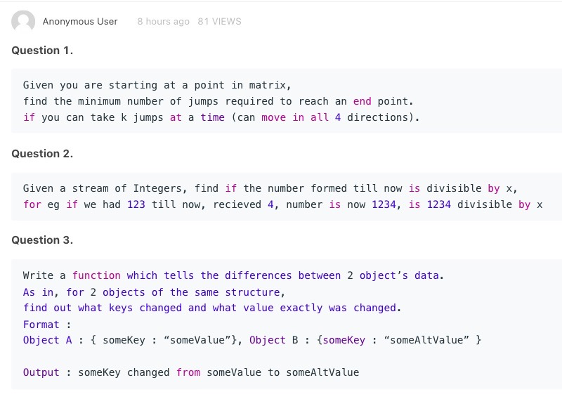





# 案例模拟：

1. 【Evercore】$10 of PIK interest expense. Could you walk me through the 3 statements?

PIK: 实物支付利息(PIK Interest)是债务的一个特征，它允许利息支出在一定年限内累积，而不是在当期以现金支付。

PIK Interest, or **“paid in kind”** interest, is a feature of debt that allows interest expense to be accrued for a set number of years, rather than being paid in cash in the current period.

作为对延期支付现金利息费用和借款人保留现金一段时间的交换，在到期日到期的债务本金增加。

In exchange for the deferred payout of the cash interest expense and the borrower retaining the cash for additional time, the debt principal coming due on the date of maturity increases.

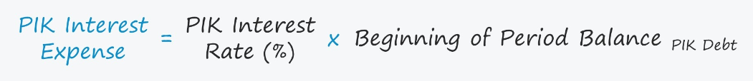

定义为贷方收取的[利息费用，该费用计入期末债务余额（本金）。](https://www.wallstreetprep.com/knowledge/interest-expense/)

选择 PIK 有助于借款人节省现金，因为利息支付被推迟到以后的日期。或者在优先股的情况下，现金股息的支付可以推迟一段商定的期限。

Opting for PIK helps the borrower conserve cash since the interest payments are pushed back to a later date. Or in the case of preferred equity, the payout of cash dividends could be deferred for a set, agreed-upon duration.

2. 【Centerview Partners】How to think about the discount rate for NOLs, merger model questions with non-round numbers?

NOL: Net Operating Losses

create a book vs. cash tax schedule and figure out what the company owes in taxes based on the Pre-Tax Income on its books, and then you determine what it pays in cash taxes based on its NOLs and its new D&A expenses (from any Asset Write-Ups). Anytime the “cash” tax expense exceeds the “book” tax expense, record this as a decrease to the Deferred Tax Liability on the Balance Sheet; if the “book” expense is higher, then record it that as an increase to the DTL.

3. 【Centerview Partners】How to think about terminal value vs. the forecast period and synergies to break even in M&A scenarios?

Terminal value: 终值是一种预测公司 未来价值 并通过贴现将其应用于当前价格的尝试。

贴现现金流 (DCF) 是可行性研究、公司收购和股票市场估值 中常用的方法。

DCF 有两个主要组成部分：预测期和终值。预测期通常为五年左右。任何比这更长的时间都会影响预测的准确性。

常用的计算终值的方法有两种：永续增长（戈登增长模型）和退出倍数。前者假设企业将永远以恒定的利率产生现金流，而后者假设企业将以某个市场指标的倍数出售。投资专业人士更喜欢退出倍数法，而学者们更喜欢永续增长模式。

To do this, you would set the EPS accretion / dilution to $0.00 and then backsolve in Excel to get the required synergies to make the deal neutral to EPS. It’s important because you want an idea of whether or not a deal “works” mathematically, and a high number for the break-even synergies tells you that you’re going to need a lot of cost savings or revenue synergies to make it work.

1. STAR: 情境(situation)、任务（task）、行动(action)、结果(result)